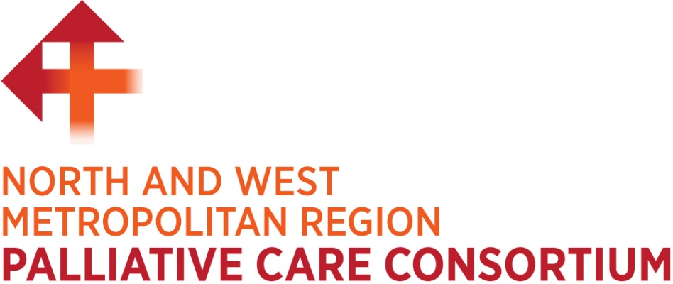

Annual Report 2020-2021



North and West Metropolitan Region Palliative Care Consortium

C/- Melbourne City Mission Palliative Care

230 Normanby Avenue,

Thornbury, Victoria 3071

Ph:03 9977 0026

Email: [consortium@mcm.org.au](mailto:consortium@mcm.org.au)

Website: [www.northwestpalliative.org.au](http://www.northwestpalliative.org.au)

**Contacts for Staff**

Kathleen Menzies, Consortium Manager, [kmenzies@mcm.org.au](mailto:kmenzies@mcm.org.au)

Michelle Warner, Project Coordinator, [mwarner@mcm.org.au](mailto:mwarner@mcm.org.au)

**CONTENTS**

1 MESSAGE FROM OUR CHAIR 5

2 OUR CONSORTIUM 6

**2.1** **HOSPITAL-BASED PALLIATIVE CARE SERVICES** 6

**2.2** **OUR COMMUNITY PALLIATIVE CARE SERVICES** 7

3 MEMBER AGENCY ACHIEVEMENTS AND CHALLENGES OVER 2020/2021 8

**3.1** **AUSTIN HEALTH** 8

**3.2** **BANKSIA PALLIATIVE CARE SERVICE** 9

**3.3** **MELBOURNE CITY MISSION PALLIATIVE CARE SERVICE** 9

**3.4** **MERCY PALLIATIVE CARE (MERCY PALLIATIVE CARE & WERRIBEE MERCY HOSPITAL)** 11

**3.5** **NORTHERN HEALTH** 12

**3.6** **PARKVILLE INTEGRATED PALLIATIVE CARE SERVICE** 13

**3.7** **WESTERN HEALTH** 14

**3.8** **NORTH WESTERN MELBOURNE PRIMARY HEALTH NETWORK** 14

4 OUR FOCUS FOR 2020-2021 – A YEAR OF CHALLENGE 14

**4.1** **OUTCOMES OF 2019/20 PROJECTS THAT CONTINUED TO 2021** 15

**4.2** **STRENGTHENING PALLIATIVE CARE IN RESIDENTIAL AGED CARE** 20

**4.2.1** **COVID-19 AGED CARE SKYPE FORUMS** 20

**4.2.2** **OUR CONSORTIUM’S ‘PALLIATIVE CARE IN AGED CARE STRATEGY ‘** 21

**4.2.3** **WORKING WITH MERCY PALLIATIVE CARE ‘CARING TILL THE END’ INITIATIVE** 22

**4.2.4** **OUTCOMES ACHIEVED IN OUR FIRST 6 MONTHS** 22

**4.2.5** **PALLIATIVE CARE IN AGED CARE STRATEGY: PROJECT EXTENSION TO JUNE 2022** 25

**4.3** **2020-2021 PROJECTS SUPPORTED BY THE CONSORTIUM** 25

**4.3.1** **MERCY PALLIATIVE CARE SERVICE REVIEW PROJECT** 25

**4.3.2** **END OF LIFE NEEDS OF PEOPLE DYING FROM COVID-19 PROJECT** 26

**4.4** **BUILDING CAPACITY** 26

**4.4.1** **TARGETED CAPACITY BUILDING INITIATIVES AND PROJECTS** 26

**Strengthening capacity to provide culturally appropriate care** 26

**Cross Sector Clinical Observational Placement Program** 27

**Working with GPs to improve quality of life of patients with life-limiting illness** 28

**4.4.2** **SUPPORTING LOCAL EDUCATION AND TRAINING WITHIN MEMBER AGENCIES** 29

**4.4.3** **EDUCATION AND TRAINING OPPORTUNITIES FOR CONSORTIUM MEMBERS** 29

**4.5** **STRENGTHENING HOW WE COMMUNICATE** 32

**4.5.1** **MAXIMISING ELECTRONIC COMMUNICATION** 32

**4.5.2** **BEING INVOLVED** 33

**4.6** **GOVERNANCE AND OPERATIONAL PRACTICE** 35

5 WHAT’S HAPPENNING IN 2021/2022 37

**5.1** **OVERVIEW OF WORK BEING UNDERTAKEN IN 2021/2022** 37

**5.1.1** **CONSORTIUM FUNDED HEALTH SERVICE INITIATIVES** 37

**Symptom Management Discharge Plans** 37

**Supportive care in Chronic Kidney Disease** 38

**Access to Aboriginal and Torres Strait Islander informed/co-designed resources** 38

**Palliative Care in Progressive Neurological Disease** 38

**Standardising Referral information between member agencies** 38

**Strengthening capacity of support workers in the disability sector to support palliative care** 38

**Funding Palliative Care education and training for Registered Nurses** 39

**5.1.2** **CONSORTIUM TEAM INITIATIVES** 39

6 FINANCIAL REPORT 40

# MESSAGE FROM OUR CHAIR



***Amy Noble***

***Senior Palliative Care Clinical Nurse Consultant***

***Parkville Integrated Palliative Care Service – The Royal Melbourne Hospital and Peter MacCallum Cancer Centre***

It gives me great pleasure as Chair of the North and West Metropolitan Region Palliative Care Consortium to present our 2020/21 Annual Report.

Over this past year, our Consortium has continued to demonstrate its collective commitment to Victoria’s end of life and palliative care framework through a range of projects, improvement initiatives and capacity building efforts. The COVID-19 pandemic and associated lockdowns has remained a disruptive backdrop to all our activities and initiatives over the past year and continues to influence how our consortium communicates and collaborates. Despite these challenges, our consortium has been very productive over the 2020/2021 period.

A key part of our work has focused on the aged care sector which has been deeply affected by the COVID-19 pandemic. Our ‘Palliative Care in Aged Care Strategy’ Project is supporting a range of strategies to address systems deficiencies as older persons move between acute health services and aged care facilities. Capacity building initiatives to strengthen the knowledge and skills of the aged care workforce are also being supported.

We continue to implement initiatives that improve palliative care systems, practice and coordination within and between acute and community sectors. Palliative care service model reviews, examining end of life needs of people dying from COVID-19, implementing initiatives that aim to strengthen capacity to provide culturally appropriate care, supporting initiatives to improve General Practitioners’ knowledge and understanding of palliative care to improve quality of life of patients with life-limiting illness are examples of work undertaken by members of our consortium over the past year.

A schedule of work for the 2021/2022 period is in place and underway. Our ‘Palliative Care in Aged Care Strategy’ Project will continue to June 2022 and we look forward to supporting our member organisations to implement a diverse range of projects and initiatives in the coming year.

Looking back on my first year as Chair of this Group, I am proud of the work we have undertaken to strengthen the delivery and quality of palliative care. I am excited and inspired by the service improvement and collaborative projects in our pipeline. I wish to congratulate members of the North and West Metropolitan Region Palliative Care Consortium on their efforts over the previous 12 months and their ongoing commitment to working together to provide high quality palliative care in our region.



***Amy Noble***

***Consortium Chair***

# OUR CONSORTIUM

The North and West Metropolitan Region Palliative Care Consortium (NWMPCC) is one of eight regional palliative care consortia funded by the Victorian Department of Health. It is an alliance of services providing palliative care for people living in the north and west metropolitan region of Melbourne.

Our catchment includes the local government areas of Banyule, Brimbank, Darebin, Hobsons Bay, Hume, Maribyrnong, Melbourne, Melton, Moonee Valley, Moreland, Nillumbik, Whittlesea, Wyndham and Yarra.

Members of the NWMPCC include hospital palliative care services, community palliative care services and the North Western Melbourne Primary Health Network (NWMPHN).

### **HOSPITAL-BASED PALLIATIVE CARE SERVICES**

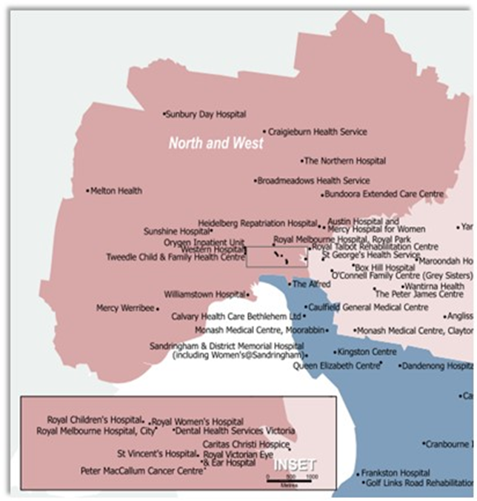Our Consortium includes five hospitals providing palliative care and consultancy services for Victorians across the north and west region of metropolitan Melbourne. These include:

* Austin Health which provides specialist palliative care to enable people with a life limiting illness to live as well as possible, including symptom management, end of life care, or discharge planning enabling them to return home. Services include an inpatient Palliative Care Unit in the Olivia Newton John Centre integrating wellness and supportive care programs; a Palliative Care Consultative Service across Austin Health; a Palliative Care Clinic; and a Palliative Care Clinical Trials program.
* Melbourne Health and [Peter MacCallum Cancer Centre](https://www.petermac.org/services/treatment/palliative-care) operating together through the Parkville Integrated Palliative Care Service of the Victorian Comprehensive Cancer Centre (VCCC) providing multidisciplinary palliative care across the Parkville Precinct including nurse consultants, specialist doctors, allied health, doctors in training and nurse practitioners.
* [Northern Health](http://www.nh.org.au/services/palliative-care-services) Inpatient Palliative Care Unit which cares for patients providing symptom assessment and management and future planning options and end of life care. The Palliative Care Consultation Service is a multidisciplinary team working together with other hospital teams to look after inpatients of The Northern Hospital Epping, Broadmeadows Hospital or Northern Health Bundoora, or who are attending a specialist clinic at the hospital.
* [Werribee Mercy Hospital (Mercy Health)](http://www.mercyhealth.com.au/hcmhs/clinics/Pages/Werribee%20Mercy%20Hospital.aspx) providing inpatient palliative care and end of life care at the Gabrielle Jennings Centre for Palliative Care and palliative care consultancy services at the hospital. The Werribee Mercy Symptom Management and Referral Team Clinic (SMART) supports patients with end-stage, life-limiting non-malignant illness, including lung disease, heart disease, renal failure and liver failure. Its multi-disciplinary team of palliative care consultants, specialist palliative care nurses and social workers deliver a holistic approach to care. Carers are invited to the clinic, recognising the important role they play.
* [Western Health](http://www.westernhealth.org.au/Services/Cancer_Services/Pages/Palliative-Care.aspx) Palliative Care Consultancy Service providing expertise and advice to patients, carers and health professionals. Services include inpatient palliative care and outpatient clinics including the SMART Clinic, a multi-disciplinary palliative care outpatient clinic which is a partnership between Western Health Palliative Care and Pharmacy Teams and Mercy Palliative Care.

### **OUR COMMUNITY PALLIATIVE CARE SERVICES**

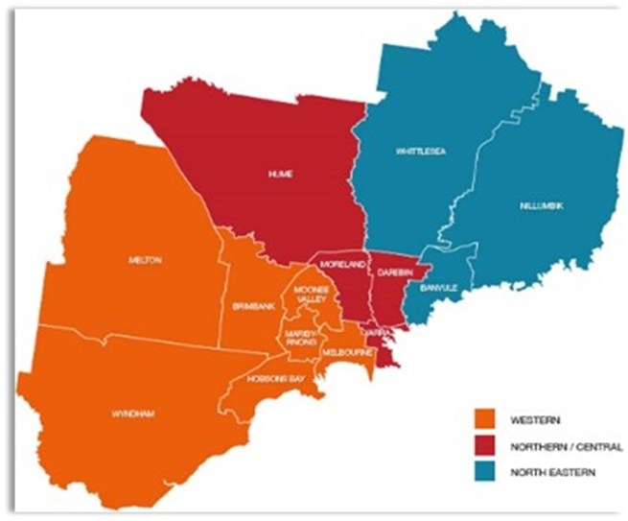Three community palliative care services provide care to the residents of specific local government areas (LGAs) across our region.

According to the Australian Bureau of Statistics, National, state and territory population December 2020, all LGAs in our catchment have experienced an increase in population over recent years. The total estimated population in our LGAs in 2018 was 2,191,199 and in 2020 was 2,305,924, an overall increase of over 114K over the 2-year period.

Our community palliative care services include:

* Banksia Palliative Care Service servicing the north-eastern part of the catchment with a total estimated population of 418,500 at 2018 rising to 433,698 in 2020, an increase of 15,198. Banksia provides specialist palliative care and practical support including coordinated expert nursing, medical and allied health services for people who have been diagnosed with a progressive terminal illness residing in the local government areas of Banyule, Nillumbik and Whittlesea.
* Melbourne City Mission Palliative Care (MCMPC) covering the north central part of the catchment with a total estimated population at 2018 of 666,249. In 2020 the population grew to 699,505, an increase of 33,256. MCMPC provides in-home palliative care services seven days a week in the cities of Hume, Moreland, Darebin and Yarra. It offers a range of nursing, medical, allied health and consulting services to help people experiencing a life-limiting illness to have the best possible quality of life.
* Mercy Palliative Care, a community-based palliative care service offering support in the north and west metropolitan region of Melbourne servicing seven municipalities including Brimbank, Maribyrnong, Melbourne, Melton, Moonee Valley, Hobsons Bay and Wyndham offering 24-hour support and advice. According to the Australian Bureau of Statistics, the population for this catchment in 2018 was estimated at 1,106,450 and rising to 1,172721 in 2020, an increase of 66,271.

# MEMBER AGENCY ACHIEVEMENTS AND CHALLENGES OVER 2020/2021

### **AUSTIN HEALTH**

Key achievements and challenges over the 2020/2021 period for Austin Palliative Care Service included:

* Maintained excellent care on the Palliative Care Unit (PCU) as reflected in regular national Palliative Care Outcome Collaborative (PCOC) reports, with plans to implement PCOC to the consult team in 2022.
* Maintained high level of inpatient PCU activity and high levels of referrals to Palliative Care Consult service.
* Expanded the Palliative Care Consult team from both nursing and medical perspectives, and reconfigured workload allocation to improve service delivery.
* Introduction of a Terminal Patient Symptom Observation Chart (TPSOC) across wards in the hospital.
* Implemented the Palliative Acute Transition Home (PATH) program in collaboration with Melbourne City Mission Palliative Care, to assist with timely transition home or admission prevention, adapting model of care to COVID-19 challenges.
* Embedded the newly formed Palliative Care research team and commenced recruitment for several clinical trials.
* Developed hospital-wide Palliative Care Education Framework, to improve generalist palliative care skills and help all clinicians to appreciate that palliative care is everybody's business.
* Performed a record number of eye donations on the Palliative Care Unit.
* Implemented a number of strategies to maintain excellent patient care while ensuring staff and patient safety during the COVID-19 pandemic including:
  + Supporting clinicians dealing directly with COVID-19 patients requiring palliative care, by developing communication guides and prescribing templates, in the inpatient and residential in-reach settings.
  + Implementing Office 365 across the hospital, allowing rapid transition of all meetings including education sessions to online platform.
  + Regular review of visitor policy for patients receiving end of life care, to balance clinical, social and ethical considerations in pandemic conditions.

### **BANKSIA PALLIATIVE CARE SERVICE**

Key achievements and challenges over the 2020/2021 period for Banksia Palliative Care Service included:

* Experienced a 20% increase in client numbers throughout the 2020/2021 financial year and delivered services to all clients without interruption to care or support.
* Provided full support to several residential aged care facilities with COVID-19 positive residents throughout the Victorian outbreak and lockdown.
* Delivered full services, including visits and after-hours care and support to all clients throughout the pandemic without incident.
* Undertook a full review of every service and process within the organisation, resulting in a robust and proven COVID-19 Service Model and development and implementation of a COVID-Safe Plan.
* Expanded the team throughout the pandemic to respond to increase service demand.
* Converted and transitioned all education sessions from face-to-face to online delivery. The service experienced and was able to respond to the increased in demand for education throughout lockdown.
* Expanded bereavement services to include bereavement walks and structured bereavement group sessions.
* Maintained a volunteer team throughout the pandemic even though volunteer duties were suspended.

### **MELBOURNE CITY MISSION PALLIATIVE CARE SERVICE**

Melbourne City Mission Palliative Care Service experienced key milestones, achievements and challenges over the 2020/2021 period including:

* Celebrating its fortieth year in operation in 2021. Melbourne City Mission Palliative Care Service was the first community-based, modern palliative care service to be opened in Victoria. Since 1981, the service has been instrumental in raising the profile of palliative care as an end of life option for Victorians. The team continue to provide dignified and compassionate care even in the face of challenges such as the COVID-19 pandemic and associated restrictions including a 66% increase in client deaths occurring at home in 2020/2021.
* Relocating its office to a larger and fit for purpose site made possible by an infrastructure grant from the Department of Health and Human Services in 2019.  The move occurred with no interruption to client management or communication systems. The new space has improved amenity and allows Melbourne City Mission Palliative Care Service to:
  + Grow its team and deliver services to more clients.
  + Expand its research program including space to conduct forums to engage with consumers.
  + Expand its Aged Care Consultancy Team.
  + Designate private spaces to allow confidential, sensitive communication with clients, carers and other service providers.
* As part of the North and West Metropolitan Region Palliative Care Consortium ‘*Palliative Care in Aged Care Strategy’,* piloting Needs Rounds in residential aged care facilities in their catchment (commenced June 2021). Needs Rounds in Aged Care:
  + Support quality palliative care and end of life care for residents in aged care.
  + Facilitate resident needs identification for palliative care support within the facility.
  + Strengthen staff capacity, skills, knowledge and confidence to provide palliative and end of life care in aged care.
  + Build awareness amongst staff of the services available to support the provision of palliative care in aged care and how and when to access these services.
* Responding to the increased demand for services including bereavement services due to COVID-19 outbreaks in aged care facilities. For example:
  + Frequent referrals were received from aged care facilities and partner hospital services including inpatient, in-reach and RAPID response teams for support of clients in the deteriorating or terminal phase who were COVID-19 positive. More referrals from aged care facilities were received due to the complex circumstances associated with COVID-19 related deaths and concerns for grieving families.
  + Responding to emerging and unmet bereavement support needs of carers from a number of facilities within its catchment which experienced high mortality related to COVID-19. The increase in complex bereavement referrals increased workload for the Melbourne City Mission Palliative Care Service counselling workforce.
  + Responding to requests from several facilities for the Aged Care Team to become involved in bereavement care for families whose loved ones had already died related to COVID-19 or died during this period when the facility had been unable to refer to Melbourne City Mission Palliative Care Service.
  + The Melbourne City Mission Palliative Care Service Aged Care and Bereavement Care Teams participated in focus groups and consultations along with other service providers (inpatient hospitals, outreach teams, palliative care peak bodies and community palliative care providers),  who shared concerns regarding the rapid and complex nature of evolving COVID-19 situations – e.g. the Precinct bereavement project with PMCC and RMH, and Bereavement Focus Group for Aged Care convened by the North and West Metropolitan Region Palliative Care Consortium.
  + Creating a COVID-19 and Bereavement Support guide for families and professionals for use across services. The guide was given to families at the time of death of a loved one.  It was provided to all COVID-19 related bereaved families supported by Melbourne City Mission Palliative Care Service and was available for use across the region.  This aided in standardising practices and responses to bereavement in all areas including community and in-reach services.
  + Contributed to the development of the Palliative Care Victoria parliamentary submission on COVID-19 impacts on Palliative Care (Victorian Government 1 Oct 2020) which highlight concerns arising from the experience of the Aged Care and Bereavement Teams during this time.

### **MERCY PALLIATIVE CARE (MERCY PALLIATIVE CARE & WERRIBEE MERCY HOSPITAL)**

In 2020, Mercy Health undertook a service review of its inpatient and community palliative care services. It identified how these services could be integrated to provide streamlined palliative care to patients.   Key achievements relating to this work included:

* Strategic consultative sessions with the workforce included model of care work and workforce review.
* Strong workforce engagement from both settings with more than 60 staff participating in project work related to the service review.
* Implementation of a single referral tool for the inpatient, community and outpatient clinic for palliative care patients.
* Alignment of key medical record documentation between community and inpatient palliative care services.
* Review and strengthening of admission and first visit processes across community and inpatient services.
* Review and strengthening of medication management across community and inpatient palliative care services.
* Utilisation of telehealth for the SMART Clinic for non-Malignant Disease.

Key challenges experienced by Mercy Palliative Care services included:

* Providing end of life care in periods of lockdown due to the COVID-19 pandemic.
* Responding to increased demand for community palliative care services. Hospital visiting restrictions resulted in increased community referrals.
* Ever changing visitor restrictions due to COVID-19 outbreaks increased the complexity of caring for patients and their families in inpatient settings. Staff had to support patients and their families when restrictions prevented contact.
* Challenges for staff in providing end of life care in full personal protective equipment.

### **NORTHERN HEALTH**

Achievements and challenges experienced by the Northern Health Palliative Care Service during 2020/2021 included:

* Year on year growth in numbers of Palliative Care Consult Team referrals of 50% since 2016 with the majority of patients having non-malignant diagnoses.
* Implementation of the Palliative Care Consult Nurse Upskilling Program developed and implemented to support a number of other nurses spending 1-2 days a week in the Palliative Care Unit. The Program was developed in response to the overall shortages of experienced palliative care staff
* Establishment of a weekly Palliative Care Outpatients Clinic in September 2020 offering telehealth and face to face reviews. The presence of a Palliative Care Clinical Nurse Consultant at Progressive Neurodegenerative Disease Clinic has been implemented and a Heart Failure Nurse Practitioner and Palliative Care Nurse Practitioner collaborative clinic established.
* The successful pilot of the Melbourne City Mission Hospital to Home project, presented at the Palliative Care Nurses Australia 2020.
* Awarding of the title of Associate Professor title to Jaclyn Yoong who has been working on the Northern Health Staff Wellbeing Survey throughout the pandemic.
* Closure of the Palliative Care Unit for 6 weeks in 2020 due to the COVID-19 outbreak. The Unit returned to full capacity in November 2020 and has continued to provide services without further interruption.
* Collaboration of Palliative Care Physician/Geriatrician leading the COVID 2 Ward for residential aged care patients and other frail patients admitted with COVID-19.
* Participation of the Palliative Care Consult Team in daily interdisciplinary COVID meetings and daily presence on COVID wards supporting generalist staff with communication, symptom control and end of life care.
* Development of End of Life Medication Packs ensuring rapid availability of end of life medications to residential aged care facilities via Residential in Reach teams and the Emergency Department.
* Development of COVID symptom control guidelines for generalist staff.
* Responding to the ongoing challenges of visitor restrictions within the hospital particularly around end of life care.
* Ongoing placements of nursing and medical students within Palliative Care through the pandemic.

### **PARKVILLE INTEGRATED PALLIATIVE CARE SERVICE**

The Parkville Integrated Palliative Care Service experienced an extremely busy and challenging 12 months. The COVID-19 pandemic directly impacted the demand for palliative care support and services. For example:

* The demand for Palliative Care consult services and outpatient clinic activities at The Royal Melbourne Hospital (RMH) and Peter MacCallum Cancer Centre increased significantly over the period.
* RMH Palliative Care Consult Service was directly involved in supporting end of life care and symptom management for COVID-19 patients at the city campus, Royal Park Campus and in residential aged care facilities.
* Palliative Care Clinical Nurse Consultant supported staff in their areas with education and debriefing opportunities.
* RAPID Assist Community Palliative Care Outreach Service worked closely with our colleagues in Residential in Reach, Hospital in the Home and Community Palliative Care Services, General Practitioners and residential aged care facilities to support urgent admissions for patients in the community and if possible, to prevent emergency admissions to hospital.
* Ever changing visitor restrictions due to COVID-19 outbreaks increased the complexity of caring for patients and their families particularly around end of life. Staff supported patients and their families when visiting restrictions prevented contact.

Other key activities and achievements include:

* An increase in inpatient services at the Parkville Integrated Palliative Care Service over the past 12 months. The 12 bed Peter Mac Palliative Care Unit - Ward 1A officially opened in September 2020. The RMH Palliative Care Unit Ward 7 West (12 beds) is currently being refurbished. Harmonisation and shared End of Life Care Guidelines have been developed and implemented across the precinct including a shared model of Palliative Care, a centralised waitlist and centralised bereavement processes. The Electronic Medical Records (EMR) was implemented across the precinct in August 2020.
* Establishment of the State-wide End of Care and Palliative Care Advice Service. This three-year project supported by the Department of Health is a phone-based service for anyone seeking specialist guidance and advice about life-limiting illness. It’s for those living with the illness and those who support them, such as family, friends and neighbours and all healthcare workers. Specialist nurses and doctors provide information about relieving symptoms, being a caregiver and the palliative care service system. For healthcare workers, the service offers guidance about prescribing, symptom management, locating appropriate services and decision-making. The Parkville Integrated Palliative Care Service at The Royal Melbourne Hospital runs the service from 7am–10pm, seven days a week. The service is free, confidential, and available for everyone in Victoria.

### **WESTERN HEALTH**

Achievements and challenges over the 2020/2021 period experienced Western Health Palliative Care Services included:

* Effectively responding to a significant surge in activity with an increased referral rate of 36% over the period.
* Having an Emergency Department Consultant spend a six-month sabbatical with the Palliative Care Consultancy Team.
* Publications in the Australian Nursing & Midwifery Journal and the Australian Health Review based on the experience of caring for patients with COVID-19 referred to the Consultancy Service.
* Electronic publication on the power of body language in nursing on the Australian Nursing & Midwifery Learning Hub website.
* Having to cancel a project that was to place a Clinical Nurse Consultant in the Emergency Department due to the COVID-19 pandemic.

### **NORTH WESTERN MELBOURNE PRIMARY HEALTH NETWORK**

Across the 2020-21 period, the North Western Melbourne Primary Health Network’s focus was threefold:

* Facilitated educational opportunities for General Practitioners and general practice workforce to improve palliative care knowledge and understanding of, and relationships with, community palliative care.
* Development of *Lately*, a co-designed digital online tool for community that provides a directory of local services, support and advice for people approaching the end of their life and the people who support and care for them.
* Commissioned the Pharmaceutical Society of Australia to implement the Palliative Care Access to Core Medicines (PCAM) model across the NWMPHN catchment. The aim of this project is to improve timely access to palliative care medications through the establishment of an agreed list of stocked palliative care medications and the delivery of clinical education.

# OUR FOCUS FOR 2020-2021 – A YEAR OF CHALLENGE

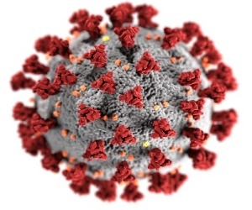The overwhelming context for the North and West Metropolitan Region Palliative Care Consortium over the 2020 - 2021 period was the COVID-19 pandemic.

Our six key priorities for 2020/2021 financial year were to:

* As far as possible, support the completion of palliative care projects and improvement initiatives commenced in 2019-2020 with member agencies.
* Design and implement a strategy to strengthen palliative care systems, processes, and practice in residential aged care facilities in our catchment.
* Support new initiatives and projects that focus on innovation, collaboration and capacity building and were consistent with one or more of the priorities of Victoria's end of life and palliative care framework:
  + delivering person-centred services.
  + engaging communities, embracing diversity.
  + coordinating and integrating services.
  + making quality end of life and palliative care everyone’s responsibility.
  + strengthening specialist palliative care.
* Source and support capacity building initiatives through the provision of palliative care education and training opportunities and other initiatives for member agencies.
* Strengthen how we communicate with our internal and external stakeholders.
* Continue to strengthen governance processes and oversight and management of Consortium operations.

### **OUTCOMES OF 2019/20 PROJECTS THAT CONTINUED TO 2021**

***PRIORITY 1 was to support the completion of palliative care projects and improvement initiatives commenced in 2019-2020 with member agencies***

The COVID-19 pandemic impacted the progress of some projects commenced in 2019-2020. We have included the following section to provide an overview of the projects that continued into 2020/2021 and have included a summary of status and achievements.

|  |
| --- |
| **HOSPITAL TO HOME PROJECT**  **Aim**: Enhance client, carer and family outcomes for palliative care clients across our catchment.  **Timeline:** July 2019 - ongoing  **Collaborating Agencies:** Banksia Palliative Care Service and Northern Health  **Outcomes:**   * Provided structured introduction to community palliative care staff and services whilst inpatient at Northern Health through an in-reach arrangement that includes a partial admission to Banksia allowing immediate access to after-hours expertise on discharge. * Facilitated streamlined, effective, delay-free discharge from inpatient units (particularly those without palliative care expertise). * Strengthened communication and collaboration across and between inpatients units, palliative care Consultancy Team and community palliative care service. * Whilst the project remains in place to enable data collection, this process is highly likely to be converted to normal business within the service model. Even though significantly affected by COVID-19 lockdowns and hospital visiting restrictions, it has proven to be a very beneficial process for clients and staff. |
| **COMMUNITY IN-REACH AND REVIEW PROGRAM**  **Aim**: Enhance client, carer and family outcomes for palliative care clients across our catchment.  **Timeline:** July 2019 - ongoing  **Collaborating Agencies:** Banksia Palliative Care Service, Austin Health, RMH/Peter Mac and Warringal Private and North Park Private  **Outcomes:**   * Provided structured introduction to community palliative care staff and services whilst in hospital through an in-reach arrangement that includes a partial admission to Banksia allowing immediate access to after-hours expertise on discharge. * Facilitated streamlined, effective, delay-free discharge from all inpatient units (particularly those without palliative care expertise). * Increased access to integrated specialist palliative care and supports in the community. * Multiple hospital engagement with several hospitals participating in the project and positive feedback from clients and carers. * Greatly improved relationships and partnerships with participating health service stakeholders (Alfred Health; RMH; RCH; St Vincent’s; Warringal Private; Epworth Richmond and St Vincent’s Private). * Project continues to collect data and the initiatives are likely to transition to a part of Banksia’s service model. Whilst significantly affected by COVID-19 lockdowns and hospital restrictions, the initiative has proven to be beneficial for clients and staff. * Recently signed Memorandum of Understanding with Austin Health will allow the project to be reactivated when COVID-19 restrictions are lifted. |
| **AGED CARE IN-REACH PROGRAM PROJECT**  **Aim**: Develop and implement a person-centred pathway of palliative care for residents with diagnosed life limiting illness from entry in to aged care to end of life.  **Timeline:** July 2019 - ongoing  **Collaborating Agencies:** Banksia Palliative Care Service and Blue Cross RACFs in Banksia’s catchment  **Current status:**   * Project was significantly affected by COVID-19 lockdown and restrictions. It was suspended for most of the 2020/2021 financial year. * Communication with participating organisations was re-established in May 2021 with a view to recommence the project in early 2021/2022 financial year. |
| **CLIENT AND CARER SUPPORT PROGRAM**  **Aim**: Provide additional support at either end of the client’s disease trajectory supporting the development of trusting relationships to optimise clients’ and carers’ experiences.  **Timeline:** July 2019 – November 2021  **Collaborating Agencies:** Banksia Palliative Care Service and Eastern Melbourne PHN  **Outcomes:**   * Successful initiative as demonstrated by funding for a further 12 months by Eastern Metropolitan PHN. * Provided dedicated and specifically structured education and support to carers who become responsible for client care in the home, including hygiene support, sourcing and use of medical equipment, and managing oral intake and medications. * Access to in-home respite, for clients who need support from a person with knowledge and skills. * Project resulted in a service model that includes Enrolled Nurses providing a range of supports including hygiene support in the terminal phase and carer education. Carers feel better equipped and supported to manage the daily care of the client until end of life. This was particularly important during COVID-19 lockdowns. |
| **HOSPITAL NURSE LIAISON PROJECT**  **Aim**: Strengthen discharge planning, communication, and referral of patients between acute and community settings.  **Timeline:** October 2019 – March 2021  **Collaborating Agencies:** Melbourne City Mission Palliative Care Service and Northern Health  **Outcomes:**   * Appointment of Melbourne City Mission Palliative Care Liaison Nurse (PCLN). * Strengthened discharge planning practices including referral to appropriate services, coordination of inpatient needs to facilitate transit to home: e.g., medication orders, equipment and care needs via OT & Physiotherapist, notifying client’s GP of discharge and commencing/updating documentation within electronic client record. * Supporting client transition to home via scheduled home appointments in the immediate period after discharge. * Quarterly reporting against baseline measures and client outcomes with the support of the North and West Metropolitan Region Palliative Care Consortium. * Key outcomes relating to client transition from hospital to home and strengthening staff relationships and understanding in the provision of client care included:   + Integrated service approach to streamline the care of newly referred and existing clients between hospital inpatient/outpatient and community settings.   + Marked improvement in referral documentation from The Northern Hospital to Melbourne City Mission Palliative Care.   + Improvement in assessment of equipment needs whilst still in hospital for clients who expressed preference to die at home.   + Improvement in the evidence of end of life discussion whilst still an inpatient and in ‘ preferred place of death’ discussions.   + Reduction in number of unscheduled presentations to Northern Health. * The outcomes of the project were presented to the Palliative Care Nurses Australia Conference in November 2020, *‘Creating a bridge between hospital and home in palliative care - using a hospital to home project’.* |
| **NON-MALIGNANT SYMPTOM MANAGEMENT CLINIC**  **Aim**: To ensure access to palliative care for patients with non-malignant disease nearing the end of their life to improve the quality of their life for patients with COPD or other life limiting respiratory diseases.  **Timelines:** September 2019 – Project delayed due to COVID-19 and recommenced January 2021  **Collaborating agencies:** Werribee Mercy Hospital – collaboration between Palliative Care Consultancy Team and Health Independence Program (HIP), Renal, Medical Units, Emergency Department and referring GPs.  **Context:**  Non-Malignant Symptom Management Clinic accepts referrals from within Werribee Mercy Hospital, with a particular focus on chronic disease sufferers who are part of the HIP, patients of Werribee Mercy Renal and Medical Units and patients who attend the Emergency Department.  Referrals are also encouraged and accepted from GPs. In February 2021, the weekly clinic commenced with a palliative care consultant and a palliative care nurse and involvement of social worker.  Key objectives of the initiative are to:   * Reduce distress from symptoms for patients in end stage of their malignant disease. * Improve seamless transition to palliative care for patients with non-malignant disease. * Provide specialist palliative support to non-malignant outpatient clinics. * Provide access to specialist palliative care support for GPs providing symptom management to patients with non-malignant disease through referral to the clinic. * Create a long-term sustainable clinic model that can be scaled to include all cohorts of patients with non-malignant disease.   **Achievements to date:**   * Clinics have had consistent referral numbers. * Clinic has established links with teams within the hospital. * Currently investigating options of continuing clinic and expanding to include malignant patients who require specialist palliative care symptom management. |
| **PALCARE GO PROJECT**  **Aim**: Develop a telehealth capability that will expand the palliative care service response.  **Timelines:** December 2019 – Completion date is March 2022  **Collaborating agencies:** Melbourne City Mission Palliative Care Service  **Context:**  Whilst the PalCare GO project was originally envisaged to target people with longer-term chronic illness, it was agreed that the platform be utilised more broadly given the challenges the COVID-19 pandemic presented. Project objectives include:   * Improved access for clients, carers and families to Melbourne City Mission Palliative Care services. * Increased capacity for clients to manage their own symptoms and gain access to information that may prevent the need for hospital admissions. * Address needs of people with chronic illness and need to manage chronic diagnosis with long term trajectories.   **Achievements to date:**   * Final stages of product development and testing of PalCare GO capability in August 2020. * Following the testing phase and pending approval of the product, Melbourne City Mission Palliative Care to pilot PalCare GO by introducing the capability to a specified number of clients.  PalCare GO will:   + be made available through the PalCare Home application that allows people to self-assess against specific symptoms, to maintain records in a diary page format, and to access up to date information on palliative care, with links to relevant websites.   + provide the capability to interact with the service via video conference.   + potentially use its telehealth capability as a communication mechanism with clients in lieu of scheduled face to face visits where safe and appropriate.  This capability is not intended to replace face to face visits.   **Status: In progress, due to complete June 2022**   * Product development and User Applied testing of PalCare GO completed October 2020 * Telehealth embedded in Melbourne City Mission Palliative Care Service response during COVID-19 in lieu of scheduled face to face visits where safe and appropriate. * Staff training underway for full implementation with 60% of staff completed training. * Evaluation of telehealth service via RAPID research program – under the guidance of Research Consultant Professor Margaret O’Connor. * Appointment of Clinical Nurse Consultant 3 days/week June 2021 for 12 months to lead next phase of project. Objectives include:   + Targeting clients living with chronic illness in the community who might benefit from palliative input but would otherwise be deemed “too early” or “too stable” to require specialist palliative care support. This can include clients who would otherwise be discharged from our service. Using the PalCare GO Home application, clients will be able to self-assess against specific symptoms, to maintain records in a diary page format, and to access up to date information on palliative care, with links to relevant websites.   + Building the capability to interact with the service via video conference.   + Engaging with internal and external stakeholders to discuss planning, service and client objectives and outcomes. |
| **AUSTIN PALLIATIVE CARE ACUTE TRANSITION HOME SERVICE (PATH)**  **Aim**: Provide a timely and coordinated response to acute palliative care needs of clients of Austin Health and Melbourne City Mission Palliative Care Service.  **Timelines:** January 2020 – December 2020  **Collaborating agencies:** Austin Health Palliative Care Service and Melbourne City Mission Palliative Care  **Outcomes:**   * The PATH model has now been incorporated into the Palliative Care Service transitioning patients from the Palliative Care Clinic, Palliative Care Unit, and the Palliative Care Consultancy onto the Melbourne City Mission Community Palliative Care Service. Benefits include:   + expediting early discharge from hospital for palliative care clients who wish to receive care at home.   + providing timely, responsive specialist palliative care to support clients to remain in the community and prevent admission into hospital.   + preventing readmissions and Emergency Department presentations by bridging gaps in service delivery. * A database has been established which collects the data and ethics approval is underway. |
| **PALLIATIVE CARE HARMONISATION AT PETER MACCALLUM & THE ROYAL MELBOURNE HOSPITAL**  **Aim**: Integration of the Peter MacCallum Cancer Centre and The Royal Melbourne Hospital workforce and care protocols to support coordinated care particularly for patients and carers moving between hospitals and from hospital to home settings.  **Timelines:** January 2020 – November 2020  **Collaborating agencies:** Peter MacCallum Cancer Centre and The Royal Melbourne Hospital  **Outcomes:**  A new 12 bed palliative care unit opened at Peter MacCallum Cancer Centre in September 2020.  While the COVID-19 pandemic impacted project progress, the following has been achieved:   * Revised and strengthened the Model of Care between both Palliative Care Units. * Development of procedures and guidelines relevant to end of life care for The Royal Melbourne Hospital and Peter MacCallum Cancer Centre and harmonisation of guidelines across the two units.  These procedures guide palliative care practice across the precinct and include admission protocols and discharge planning. * Collaboration between The Royal Melbourne Hospital and Peter MacCallum Cancer Centre Social Workers, Spiritual Care, Senior Nursing Staff - Senior Palliative Care Clinical Nurse Consultant, and both Nurse Unit Managers from both Palliative Care Units and Community Palliative Care Services Bereavement Counsellors from Melbourne City Mission Palliative Care, Mery Palliative Care, Banksia Palliative Care and Eastern Palliative Care.  Working group established to support the harmonisation and process across the Units and develop tools and guidelines.  Bereavement assessment is based on the DHHS Bereavement Support Guidelines and will be part of Electronic Medical Record. * Workforce harmonisation including options around work experience in each area of palliative care practice and undergraduate programs and potential collaborative research opportunities. * Staff education and training on the strengthened model of care and new procedures and guidelines underway. |

### **STRENGTHENING PALLIATIVE CARE IN RESIDENTIAL AGED CARE**

***PRIORITY 2 was to strengthen palliative care systems, processes, and practice in residential aged care facilities in our catchment starting with Aged Care Skype forums.***

### **COVID-19 AGED CARE SKYPE FORUMS**

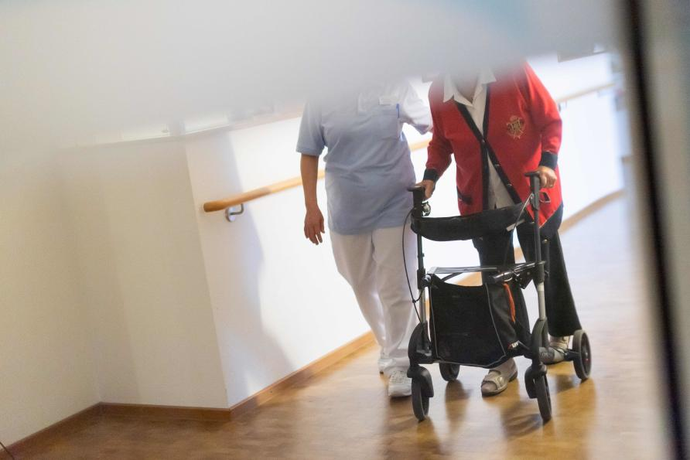The impact of the COVID-19 pandemic over the 2020-2021 period was significant for residents, families and staff in residential aged care and acute hospital settings in the north and west metropolitan region of Melbourne.

In response, our Consortium established COVID-19 Aged Care Skype Forums in April 2020 to provide clinicians from acute and community sectors working in the residential aged care space with an opportunity to:

* share experiences, issues and solutions in response to barriers and challenges when providing palliative care and support to residential aged care facilities.
* support capacity building in residential aged care around end of life care.
* share tools, resources and practice models.

Forum Membership included palliative care representatives from each of our member organisations including Community Palliative Care Aged Care team members, Residential-In-Reach clinicians, Geriatricians, Palliative Care Physicians and Palliative Care Clinical Nurse Consultants. A representative from Safer Care Victoria also attended most forums.

Areas of discussion and information sharing included responses to outbreaks in aged care facilities in our north and west catchments, approaches to managing visiting restrictions, strategies implemented in response to the lack of access to bereavement services in residential aged care and activities being undertaken by Safer Care Victoria for the residential aged care sector.

A short-term bereavement focus group was established in response to visiting restrictions and lack of access to bereavement support for families who experienced the death of their loved one in an aged care facility. Members of this group shared how they were managing service demand and provided a range of information, data and feedback to Palliative Care Victoria and Palliative Care Australia to inform the content of briefing papers for submission to State and Federal Governments for funding and bereavement support.

Eight aged care forums were conducted between April 2020 and November 2020 with each forum well attended. Feedback from participants and strong attendance demonstrated the benefits of the forum. Participants valued the discussion and the opportunity to share information, resources and solutions.

Towards the end of 2020, forum participants confirmed the need for a strategic approach to strengthen palliative care access and practice in residential aged care in our catchment. It was agreed that strategies and solutions needed to be sustainable and inclusive and bring together stakeholders from residential aged care, the acute sector, community palliative care, GPs, in-reach services and consumers.

In response to this feedback from the Skype Forum, the Consortium Team presented the *Palliative Care in Aged Care Strategy* to the Consortium Management Group for consideration in November 2020. The Consortium Management Group approved funding of a six-month initiative which included the appointment of a part time (0.6 EFT) Project Officer to implement a range of sector engagement and capacity building activities in residential aged care. A senior Clinical Nurse Consultant was appointed to the role and commenced work in January 2021.

### **OUR CONSORTIUM’S ‘*PALLIATIVE CARE IN AGED CARE STRATEGY* ‘**

The key planks of our ‘*Palliative Care in Aged Care Strategy’* include:

* ***Sector Engagement Aim***: Residential aged care leaders and staff and other key stakeholders including Residential-In-Reach, GPs, representatives of Specialist Palliative Care Consultancy services and Community Palliative Care actively seek out and participate in improvement initiatives, projects and forums relating to strengthening palliative care in residential aged care.
* ***Knowledge/Capacity Building Aim:*** Residential aged care managers and their workforce seek and participate in education and training opportunities that build awareness, knowledge and skills to support the effective and appropriate provision of palliative care in residential aged care.
* ***Collaboration Aim:*** Palliative care related projects and improvement initiatives support collaboration between residential aged care organisations and community and inpatient palliative care and primary care service providers.
* ***Evaluation Aim:*** Aims and outcomes of this strategy are measured and monitored, and improvements are designed to be sustainable beyond the life of the project.

### **WORKING WITH MERCY PALLIATIVE CARE ‘*CARING TILL THE END’* INITIATIVE**

In February 2021 our *Palliative Care in Aged Care Strategy* merged with Mercy Palliative Care’s 2019 Innovations project known as ‘*Caring till the End’* which had been on hold due to COVID-19.

This collaboration was agreed by the Department of Health and Human Services and the Consortium Management Group.

The ‘*Caring till the End’* Project Officer works with the Consortium’s *Palliative Care in Aged Care Strategy* Project Officer to implement consistent strategies and processes across the Consortium’s catchment.  This ensures a coordinated response across the north and west metropolitan region and builds capacity and improves palliative care in the aged care settings in a coordinated and consistent manner.

### **OUTCOMES ACHIEVED IN OUR FIRST 6 MONTHS**

An overview of outcomes achieved in our first 6 months of the *Palliative Care in Aged Care Strategy* is presented in the following table:

|  |  |
| --- | --- |
| **Key Planks** | **Outcomes achieved** |
| ***Sector engagement*** | * Aged Care Advisory Group established: Excellent sector and stakeholder representation and engagement. Membership includes Residential Aged Care Facilities (RACFs), Community Palliative Care, In-Reach, General Practitioners, Aged Care Assessment Service, Palliative Care Consultancy Services, Geriatricians, End of Life Directions for Aged Care (ELDAC), Palliative Care Outcomes Collaboration (PCOC) and Elder Rights Advocacy. * 5 Meetings scheduled in the first half of the year and all conducted (February 2021 to June 2021) with good to excellent attendance – average 75% * *Palliative Care in Aged Care Strategy* e-Newsletters first published April 2021. Content focuses on updates and activities around the key elements of the strategy: Sector Engagement, Collaboration and Capacity Building. Distributed to 180 RACFs in the catchment and subscription encouraged. Monthly publications demonstrating increasing subscriptions.  |  |  |  |  |  | | --- | --- | --- | --- | --- | | **Month** | **April** | **May** | **June** | **July** | | **Subscriptions** | 40 | 91 | 95 | 138 | | **Opens** | 38.5% | 50% | 43% | 31% | | **Clicks** | 15 | 26 | 22 | 15 |  * . Project Leads contacts conducted demonstrating strong engagement across the sector: * **RACFs**: Regular contact re needs rounds, education opportunities, participation in focus groups and exploration regarding anticipatory medication issues. * **GPs**: Discussion around Advance Care Planning, Goals of Care (GoC), Handover, family communication, discharge summaries and anticipatory medication orders. * **RAPID Assist/Residential In Reach**: Regular discussions re needs rounds, infusion management, anticipatory medication prescription, symptom management, collaboration opportunities with Community Palliative Care and RACF staff education. * **Community Palliative Care**: Regular discussions re needs rounds, infusion management, anticipatory medication prescription, symptom management, collaboration opportunities with RAPID/Residential In-Reach, RACF staff education. * **Advance Care Planners**: initial contact to understand current practice and GoC use in RACFs. * **NWMPHN**: Gap identification, meetings regarding anticipatory medication management, ongoing discussions to explore collaborative opportunities to engage with GPs regarding palliative care. * **ELDAC**: Agreed with ELDAC to work with RACFs in our catchment selected to be part of ELDAC’s Working Together Program to progress Program Objectives. * **Elder Rights Advocacy**: Meetings with family members to capture consumer voice, issues and concerns. Positive feedback from consumers regarding the opportunity to be part of same. Shared feedback with Aged Care Advisory Group. * **Pharmacies**: Consultation regarding anticipatory medication imprest guidelines and stores and impact of Royal Commission guidelines regarding psychotropic medications. * Excellent uptake to be part of working/focus groups for Handover and Infusions Devices for Symptom Management. * Wholesale review and refresh of content and tools in the Palliative Care in Aged Care page on Consortium website. * Project Officer member of two Safer Care Victoria working groups on Deterioration and WAVE and member of working group for Pharmaceutical Society of Australia (PSA) regarding the Palliative Care Access to Core Medicines (PCAM) model. |
| ***Knowledge and Capacity Building*** | * Documented ‘steps’ for RACFs and other stakeholders showing how to support capacity building in RACFs using existing education and learning portals and resources.      * Documented ‘trajectory graph’ for RACFs and other stakeholders showing how documentation and regular review of GoC are essential for a good death.      * Distribution of ‘steps’ and ‘trajectory graph’ to RACFs and other stakeholders – via newsletter, on website and direct email. * Agreed performance indicators to demonstrate uptake of ‘Steps to improve Palliative Care Practice in Aged Care’ framework. * Seven RACFs involved in ELDAC’s Working Together Program in our catchment. Our Project Officers to be part of their local ELDAC working groups. * Comprehensive health assessment of the older person workshops x 2 conducted by La Trobe University (43 participants) fully subscribed within days of being promoted. Excellent feedback from participants. Scheduled 3rd Workshop delayed until October 2021 due to COVID-19 lockdown. This workshop is fully subscribed. Consortium agreed to fund 4th workshop scheduled for November/December 2021. * Commenced development of Toolbox Animation Webinars to be accessible online for RACFs. Topics include Needs Rounds, Handover/GoC – scheduled for release late 2021. |
| ***Collaboration*** | * Medication Imprest System guidelines developed. Reviewed by Pharmaceutical Society of Australia to ensure appropriate and circulated via our Palliative Care in Aged Care Newsletter and to our Aged Care Advisory Group. * Needs Rounds: * Briefing documents established including methodology. * Needs rounds established in three RACFs in Melbourne City Mission and Mercy catchments. * Outcome measures developed. * Active engagement and involvement from In-Reach from the Royal Melbourne Hospital, Melbourne City Mission Palliative Care and Mercy Palliative Care, Western Health and Werribee Mercy. * Handover Focus Group established to identify opportunities to strengthen discharge planning and communication practice - wide representation from across the sector. * Use of Infusion Devices in RACFs to support symptom management Focus Group established to develop agreed guidelines for RACFs in the catchment. |
| ***Evaluation*** | * Key performance indicators and performance measures for each main objective developed. Status is regularly monitored, captured and reported to Consortium Management Group at monthly meetings. |

### **PALLIATIVE CARE IN AGED CARE STRATEGY: PROJECT EXTENSION TO JUNE 2022**

In May 2021, a proposal was tabled at the Consortium Management Group to extend our *Palliative Care in Aged Care Strategy* and the role of the Project Officer to June 2022. This was approved. The Group agreed the extension will provide time to build on the work undertaken in the first six months and allow the Project Officers to engage directly with RACFs and implement capacity building strategies.

### **2020-2021 PROJECTS SUPPORTED BY THE CONSORTIUM**

***PRIORITY 3 was to support new initiatives and projects that focus on innovation, collaboration and capacity building and were consistent with one or more of the priorities of Victoria's end of life and palliative care framework.***

### **MERCY PALLIATIVE CARE SERVICE REVIEW PROJECT**

Mercy Palliative Care conducted a service review in late 2019/early 2020 to identify the ability of the organisation to manage the increasing demand for palliative care in the region. The report identified that while the current services provided good care, they were working in some degree of separation.

The aim of the Mercy Palliative Care Service Review Project was to develop an integrated service model of care across Mercy Health Palliative Care to ensure all consumers receive and experience standardised high-quality care and seamless service provision across the continuum of care in all settings. The project commenced July 2020 and the Consortium funded resources to undertake improvement initiatives. Key outcomes achieved to date include:

* Development of a single referral tool across community, outpatient and inpatient services.
* Development of pre-admission assessment used across all settings.
* Implementation of RUN PC across all settings.
* Single admission procedure developed for palliative care services.
* Development of admission criteria.
* Review of website information.
* Investigation of e-referral (ongoing).

### **END OF LIFE NEEDS OF PEOPLE DYING FROM COVID-19 PROJECT**

The Victorian Comprehensive Cancer Centre (Peter MacCallum Cancer Centre and The Royal Melbourne Hospital) was funded by the Consortium to undertake a project to describe the demographics, symptoms experienced, and supportive care needs including general nursing care needs, oxygen requirements, pressure area care, and medication needs for patients in the final 72 hours of life, dying from COVID-19 disease.

The Project commenced January 2021 and includes retrospective chart review of all deaths due to COVID-19 across The Royal Melbourne Hospital, Northern Hospital, Western Hospital, Werribee Mercy and Austin Hospital, and their associated in-reach services and hospital-in-the home services, from 1 January 2020 to 30 October 2020.

Data collection has occurred from partnering agencies: Northern Health, Western Health, Austin Health and The Royal Melbourne Hospital and Werribee Mercy and is expected to be completed in September 2021. Statistical review and analysis of the data will occur in October 2021 and reporting of findings is planned for the end of 2021.

### **BUILDING CAPACITY**

***PRIORITY 4 was to source and support capacity building initiatives through the provision of palliative care education and training opportunities and other initiatives for member agencies.***

Three key approaches were implemented by our Consortium to build and strengthen the capacity of the member organisation’s workforce in relation to palliative care practice, skills and knowledge and resilience. These include:

* Targeted capacity building initiatives and projects through three initiatives.
* Provision of funds to member organisations to support access to and delivery of palliative care related education and training.
* Sourcing and funding palliative care related education and training opportunities for Consortium members.

### **TARGETED CAPACITY BUILDING INITIATIVES AND PROJECTS**

### **Strengthening capacity to provide culturally appropriate care**

The ‘*Strengthening the capacity of community palliative care to provide culturally appropriate care to patients from Culturally and Linguistically Diverse (CALD) backgrounds’* initiative began in January 2021 and was implemented by the Consortium Manager and Consortium Project Coordinator/Administrator.

A small Focus Group was convened comprising representatives from our three community palliative care services to explore strategies to strengthen knowledge and practice when providing palliative care to culturally diverse communities. The initiative is ongoing and key outcomes achieved to June 2021 include:

* Comprehensive review and refresh of the Consortium’s culturally and linguistically diverse resources and information on its webpage.
* PEPA education and training for 15 staff from Consortium member agencies on cultural diversity and palliative care in May 2021.
* In collaboration with the Centre for Culture, Ethnicity & Health (CEH), identification of emerging communities in the Consortium’s catchment where information and knowledge around advance care planning, death and dying and palliative care is unknown or limited. A Focus Group of religious leaders from the Muslim community is scheduled for September 2021 to explore their perceptions and information needs regarding advance care planning, death and dying, palliative care and end of life care. Outputs from this group will inform practice guidelines and the development of tools and resources to support culturally appropriate palliative care practice for this emerging community. These resources will be made available across the Consortium and more widely. This approach will be evaluated and if proven effective, will be replicated for other emerging communities in our catchments.

### **Cross Sector Clinical Observational Placement Program**

In January 2021, the North and West Metropolitan Region Palliative Care Consortium team commenced work on establishing the Cross Sector Clinical Observational Placement Program, supporting observational placements of palliative care clinicians between our acute and community settings.

The Program differs from PEPA Placements in that it focuses on increasing cross sector understanding of palliative care services, service models and practices within our region. It will allow participants to observe the provision and delivery of palliative care in other palliative care sectors in their catchment. It aims to increase participants’ understanding of models of care in different settings, and further develop skills and knowledge in the areas of clinical and psychosocial practice and communication in these settings.

The objectives of the Program are to:

* raise awareness and understanding of the models of palliative care, work practices, systems, processes, and challenges in palliative care settings.
* through observation of various communication styles and strategies, strengthen participants communication skills when delivering difficult and challenging information to patients and families.
* strengthen collaboration, communication and cooperation between and across settings that provide palliative care within the North and West Metropolitan Region Palliative Care Consortium.

The potential benefits of the Program include:

* Improved awareness and understanding of sector models of palliative care and practices across workforces.
* Enhanced cooperation between palliative care service providers and sectors within our catchment.
* 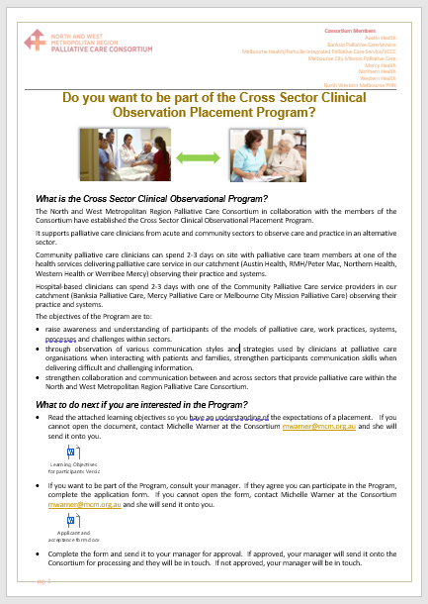Strengthening seamless patient transition between care sectors supporting improved patient and family experiences.
* Raised profile of palliative care as a career path with the potential to increase recruitment from outside existing palliative care workforce.

Program evaluation and performance measures to assess the impact and benefits of the Program are in place.

The Consortium Team is responsible for Program administration and coordination and will work in collaboration with nominated local Program Coordinators at each member organisation.

To date, four of the seven consortium member agencies have agreed to be part of the Program which will be launched once COVID-19 lockdown restrictions are eased.

### **Working with GPs to improve quality of life of patients with life-limiting illness**

In September 2020, the North Western Melbourne Primary Health Network partnered with the North and West Metropolitan Region Palliative Care Consortium to offer General Practices in our catchment, the opportunity to connect with local community based palliative care providers.

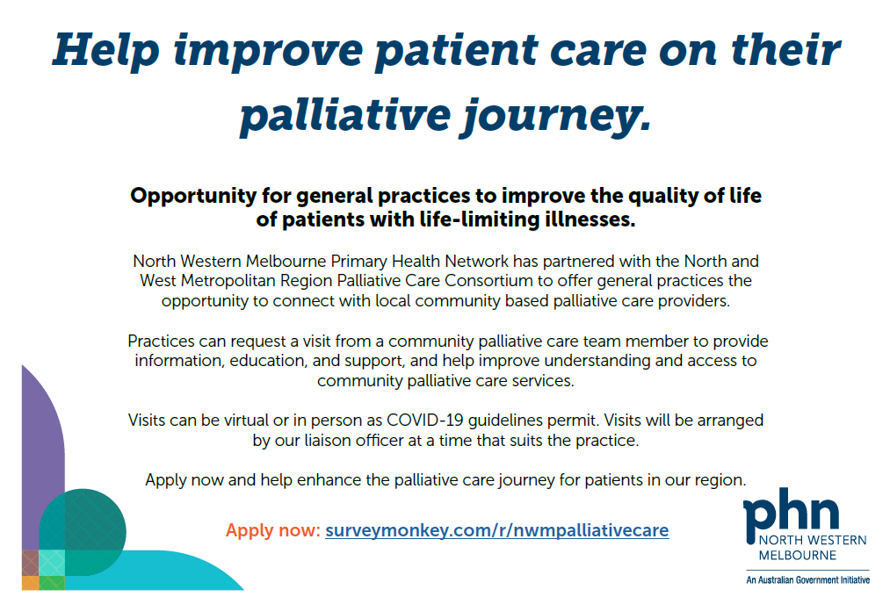General Practices could request a visit from a community palliative care team member to provide information and education about community palliative care and help improve understanding and access to community palliative care services. Visits were conducted virtually given COVID-19 restrictions.

While uptake of this initiative was slow due to COVID-19, with only four visits conducted to June 2021, feedback from participants has been excellent. An additional two visits occurred in July 2021. Further promotion of this initiative is planned post COVID-19 restrictions given the excellent feedback from participating GPs and Practice Nurses.

### **SUPPORTING LOCAL EDUCATION AND TRAINING WITHIN MEMBER AGENCIES**

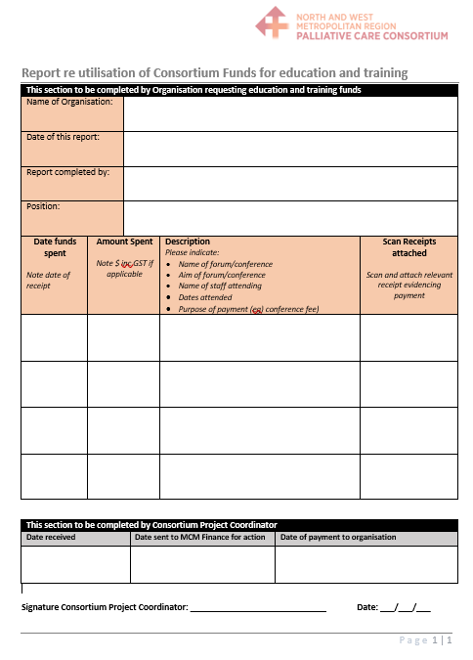Our Consortium supported local education and training opportunities. The Consortium Management Group approved the provision of $6,000.00 for each member organisation to access and deliver palliative care education and training opportunities within their organisations.

Each member organisation provided an annual report detailing how these funds were utilised including scanned receipts.

Examples of use of funds included but were not limited to conference attendance, external education and training programs with associated costs, cost of speakers for specific education sessions for staff groups relating to palliative care; resourcing a study day for palliative care staff and staff attendance at masterclasses.

### **EDUCATION AND TRAINING OPPORTUNITIES FOR CONSORTIUM MEMBERS**

Our Consortium also sourced and funded a range of education and training for members over the 2020/2021 period.

The COVID-19 Pandemic restricted how education and training could be delivered. Lockdowns and restrictions meant that member organisations were unable to attend face to face training. Workforce shortages because of redeployment, increased unplanned leave (furloughs) and workforce pressures decreased staff availability to attend sessions, even virtually.

Despite these challenges, the North and West Metropolitan Region Palliative Care Consortium continued to support capacity building opportunities.

The provision of virtually delivered learning opportunities and programs specifically targeted to build the resilience of the workforce to effectively respond to the pressures and challenges of COVID-19 were sourced and scheduled. The uptake of virtual courses was strong. Where possible, face to face training was also sourced and funded.

The following provides an overview of the education and training sourced and provided through our Consortium over 2020/2021 period.

|  |
| --- |
| **COMPREHENSIVE HEALTH ASSESSMENT OF THE OLDER PERSON: PRACTICAL 3 DAY WORKSHOP**  Conducted by La Trobe University Australia Centre for Evidence Based Aged Care (ACEBAC) - 18, 19, 20 May 2021 and 15, 16, 17 June 2021. A total of 43 nurses working in Residential Aged Care and In-reach services in our catchment attended the workshops. Comments from participants:   * *“Knowledge of compliance and assessment of older person thoroughly taught.”* * *“Good refresher, new assessment techniques a lot learned to take back to staff.”* * *“Enjoyed the whole training and learnt a lot.”* * *“Gaining a better understanding of how to assess heart and lungs.”* * *“Refreshed my knowledge and skills in assessing the older person. Learned skills and techniques while doing assessment and able to detect early signs of deterioration.”* * *“Heart and lung assessment was useful.”* * *“Upskill and able to go back to the facility with more knowledge and confidence.”* * *“The course offered a fantastic refresher on how to conduct a holistic head to toe assessment. Highlighted the value of a proper assessment.”* * *“Cardiac and breathing sounds refresher.”* * *“Increased knowledge and understanding of all systems covered in the course. It will help provide better care to residents and assess and provide early interventions to residents as needed.”* * *“Revised and refreshed on not only comprehensive assessing residents but really knowing them as a person.”*   Evaluation demonstrates excellent feedback:    Given the demand for these workshops, a third is scheduled for October 2021, the lockdown permitting. The third workshop was fully subscribed within four days of notification to the aged care sector. The Consortium has agreed to fund a fourth workshop in late 2021, given the uptake of the workshops and the positive feedback from participants. |
| **CULTURED CENTRED CARE WORKSHOP**  Conducted by PEPA on 11 May 2021 for workforce from member agencies of our Consortium. Fifteen participants attended and their feedback was very positive:   * *“Great presenter, knowledgeable, shared stories and anecdotes”* * *“Excellent presentation”* * *“Group examples”* * *“Interactive”* * *“Accessible”* * *“Informative”* |
| **SELF-COMPASSION TRAINING FOR HEALTHCARE COMMUNITIES**  6-week online program conducted by expert facilitator – focused on reducing stress and burnout, in challenging times. Delivered from April 2021 to May 2021. Feedback from the 11 participants included:   * *“The online experienced worked very well, I would not have been able to attend in person.”* * *“The course was customized to health sector workers so it was very relevant.”* * *“The facilitator was excellent as a facilitator being compassionate to participants, communicating very well the theory and practices.”* * *“Excellent and thanks to the consortium or funding.”* |
| **DIFFICULT CONVERSATIONS**  Delivered as on-line webinar delivered by Deakin University Centre for Organisational Change in Person-Centre Healthcare on 16 July 2020 with 16 participants.  **COMMUNICATING BAD, SAD OR UNWANTED NEWS WITH PATIENTS AND FAMILIES BY TELEHEALTH**  Delivered as on-line webinar delivered by Deakin University Centre for Organisational Change in Person-Centre Healthcare on 10 November 2020 with 21 participants.  **END-OF-LIFE CONVERSATIONS: FUNDAMENTALS OF LEGISLATION AND COMPLEX CONVERSATIONS**  Delivered as on-line webinar delivered by Deakin University Centre for Organisational Change in Person-Centre Healthcare on 2 June 2021 with 11 participants.  Feedback from participants for above sessions was very positive:   * *“I learned new skills but also reinforced thoughts I had. I felt comfortable in the environment and thus open to learning.”* * *“The workshop was fantastic. It was highly engaging with a high content of very practical information given in a short space of time. Fantastic!”* * *“Course contents relevant for work and will be good if more people are able to do this via this mode of teaching. No hassle, at home or office and in a comfort zone and save time travelling.”* * *“This session comes at the perfect time in healthcare to brush up our skills. The dynamic and knowledgeable presenters ensure the material is engaging and relevant.”* * *“Very helpful at this challenging time in health.”* |

### **STRENGTHENING HOW WE COMMUNICATE**

***PRIORITY 5 was to strengthen how we communicate with our internal and external stakeholders.***

### **MAXIMISING ELECTRONIC COMMUNICATION**

Our Consortium has implemented initiatives to strengthen how we communicated with our stakeholders including:

* a wholesale review and restructure of our website, editing content, improving navigation, and ensuring information and resources are current, relevant and easy to find.
* publishing a monthly Consortium e-newsletter which includes information and resources, events and education and training information relating to palliative care. Data demonstrates increasing subscriptions since its first publication in May 2021. Strategies to promote subscriptions are now being implemented which include sending broadcast emails to our stakeholders advising them of the latest newsletter and the updated website and adding subscription links to our email signatures.

|  |  |  |  |  |
| --- | --- | --- | --- | --- |
| **Month** | **May** | **June** | **July** | **August** |
| **Subscriptions** | 92 | 95 | 139 | 142 |
| **Opens** | 45.3% | 47.3% | 34.1% | 47% |
| **Clicks** | 26 | 19 | 16 | 18 |

* broadcast distribution via emails of notifications regarding education and training opportunities, webinars, and forums, key sector information etc.
* ensuring the collection and timely distribution of comprehensive and accurate information arising from all internal and external virtual meetings and forums and prompt distribution of agendas and minutes of meetings to stakeholders.

### **BEING INVOLVED**

Representatives of our Consortium Management Group have been actively involved in external groups and committees, supporting the COVID-19 response and presenting at conferences over the year.

|  |
| --- |
| **WESTERN & CENTRAL MELBOURNE INTEGRATED CANCER SERVICE (WCMICS)**   * The North and West Metropolitan Region Palliative Care Consortium Chair and Consortium Manager are members of the Western & Central Melbourne Integrated Cancer Service Governance Committee. The role of the Governance Committee is to provide leadership, vision and overall accountability for the Western and Central Melbourne ICS, ensuring an integrated and collaborative approach to consistent high-quality cancer care in Victoria. The Chair and the Manager attended quarterly meetings in 2020/21 and contributed to discussions relating to palliative care. * The Consortium Manager meets regularly with the Manager of WCMICS to explore opportunities to collaborate and share information about work being undertaken by each agency. |
| **INNER NORTH WEST PRIMARY CARE PARTNERSHIP GOVERNANCE GROUP**  The North and West Metropolitan Region Palliative Care Consortium Manager is a member of the Inner North West Primary Care Partnership Governance Group.  The role of the Governance Group is to:   * develop, implement, and monitor strategic directions. * Further develop robust governance systems and process. * Take responsibility for the Primary Care Partnership/PCP internal accountability. * Implement appropriate management structures and processes for the PCP to enable planning and effective change within and between partner agencies and the broader health and human/community services system. * Provide decision making with respect to the PCP planning, priorities, and activities. * Actively support the PCPs vision and core values. * Communicate with PCP members and stakeholders.   The Consortium Manager attended bi-monthly meetings in 2020/21 and contributed to discussions relating to governance of the organisation and information about palliative care and the role of the Consortium. |
| **CONTRIBUTING TO COVID-19 RESPONSE**   * Palliative Care in the Care of Older People Clinical Network SCV COVID Expert Working Group (EWG) commenced in July 2020 and met weekly. This EWG provided advice during the peak of the COVID-19 pandemic outbreaks. Palliative Care clinicians from The Royal Melbourne Hospital were members of this Group, contributing their insights and recommendations regarding care of the older person in aged care in the context of COVID-19. * The Director of Nursing from the Royal Melbourne Hospital led the Aged Care Outbreaks Response as the representative directed by Department of Health and Human Services. A senior nursing representative from the Palliative Care team was nominated as the senior Palliative Care CNC. The RAPID Palliative Care Outreach team was also directly involved in providing care in residential aged care facilities. * Palliative Care Clinicians from The Royal Melbourne Hospital:   + assisted several RACFs experiencing COVID-19 outbreaks at the Royal Park Campus and City Campus in business hours and after hours, providing palliative and end of life care and consultative advice to Residential In Reach, RACFs staff and GPs, mainly via telehealth.   + provided palliative care nursing education and debriefing sessions to clinicians at The Royal Melbourne Hospital – City Campus and Royal Park, COVID wards and other wards, Aged Care Facilities, In-reach Services. |
| **CONFERENCE PRESENTATIONS**   * Palliative Care Nurses Australia Conference Virtual Conference in November 2020:   + *‘Reflections on the Victorian voluntary assisted dying legislation’.* Oral presentation by Professor Margaret O’Connor – Research Consultant, Melbourne City Mission Palliative Care.   + *‘Creating a bridge between hospital and home in palliative care - using a hospital to home project’.* Oral presentation by John Doran – Senior Manager, Melbourne City Mission Palliative Care.   + *‘From invisible to visible – the hidden role of carers’.* Oral presentation by Suzanne Peyton Clinical Educator – Palliative Care, Melbourne City Mission Palliative Care.   + *‘Making Palliative Care everyone’s business in residential aged care: a local improvement approach to strengthen palliative care practice’.* Oral presentation by Kathleen Menzies, Consortium Manager. * Dr Maria Coperchini, Director Palliative Care - Western Health presented to MD Student Conference (University of Melbourne) in June 2021 on ‘*Life’.* * ANZSPM Conference September 2020:   + *‘Implementation of a terminal phase symptom observation chart in subacute geriatric medicine wards: A quality improvement approach’ –* Poster presentation by Aaron B Wong, Palliative Medicine Physician – Austin Health.   + *‘Prevalence and sites of pain in remote-living older Aboriginal Australians, and associations with depressive symptoms and disability’ –* Poster presentation by Aaron B Wong, Palliative Medicine Physician – Austin Health. * ANZSGM Annual Scientific Meeting May 2021   + *‘Prevalence and sites of pain in remote-living older Aboriginal Australians, and associations with depressive symptoms and disability’ -* Oral presentation by Aaron B Wong, Palliative Medicine Physician & Geriatrician – Austin Health.   + *‘Implementation of a terminal phase symptom observation chart in subacute geriatric medicine wards: A quality improvement approach -* Poster presentation by Aaron B Wong, Palliative Medicine Physician & Geriatrician – Austin Health. |
| **SAFER CARE VICTORIA**  Our Palliative Care in Aged Care Strategy Project Officer contributed to:   * *‘We are Ambulance Victoria Engaged’* - The WAVE Project focused on improving the provision of home-based end-of-life care through increased collaboration between community palliative care services and paramedics. * *‘Early recognition of clinical deterioration in aged care’* project which sought to review and recommend best practice in early recognition of clinical deterioration and develop and test a screening tool for use in residential aged care. |
| **PALLIATIVE CARE AUSTRALIA/VICTORIA**  Our member agencies provided reports and data around access to Bereavement Services for families of residents who died in residential aged care. This information was used to inform submissions to the:   * Inquiry into Victorian Government’s Response to the COVID-19 Pandemic by Palliative Care Victoria. * COVID-19 and Palliative Care: Grief, Bereavement and Mental Health Issues by Palliative Care Australia. |
| **CONSORTIUM MANAGERS MEETINGS**  Regular meetings with other Consortium Managers and the Consortia Aged and Disability Group were undertaken to provide information about the work being undertaken by our Consortium, to share ideas and hear about the work of other Consortia. |

### **GOVERNANCE AND OPERATIONAL PRACTICE**

***PRIORITY 6 was to continue to strengthen governance processes and oversight and management of Consortium operations***.

Over the past 12 months our Consortium has continued to strengthen governance processes and operations through:

* Revision of the Memorandum of Understanding (MoU) to ensure clarity and transparency regarding corporate costs applied by the fundholder. All members have signed the MoU.
* Savings in annual operational costs of at least $20k per annum through:
* renegotiation of corporate support costs capped at $30K, a cost saving of at least $10K per annum. Previously MCM, the Consortium’s fundholder assessed costs at the end of each year based on total income, including prior year balance carried forward minus total expenditure. Over previous years this was at least $39K or more.
* ceasing office rental agreement with fundholder with a cost saving of approximately $10K per annum. The Consortium Team comprising the Manager, Project Coordinator/Administrator and Project Officer have been working remotely since the beginning of the pandemic. Effective systems have been implemented by the Manager to ensure timely, regular, and appropriate communication within the team and achievement of operational outcomes and outputs.
* Building on previous improvements, further strengthening Consortium Management Group functions including:
* annual review of our Terms of Reference undertaken as scheduled with minor amendments.
* excellent member engagement as demonstrated by 10 out of 11 scheduled Consortium Management Group meetings conducted (91%) and average attendance rate of 86% (refer below to monthly attendance % over 2020/2021 period).

|  |  |  |  |  |  |  |  |  |  |  |  |
| --- | --- | --- | --- | --- | --- | --- | --- | --- | --- | --- | --- |
|  | **July 2020** | **Aug 2020** | **Sept 2020** | **Oct**  **2020** | **Nov 2020** | **Dec 2020** | **Feb 2021** | **Mar 2021** | **Apr**  **2021** | **May 2021** | **Jun**  **2021** |
| **% Attendance** | 66% | 66% | 100% | 100% | 89% | 100% | 100% | 78% | Cancelled | 78% | 89% |

* seeking nomination of proxies from members when unable to attend monthly meetings. This supports member agency representation, participation and transparent decision making.
* Table

  Description automatically generatedpreparing and presenting briefing papers to ensure members are informed of rationale and scope of proposed initiatives. Examples of briefing papers include Cross Sector Clinical Observational Placement Program; Improving capacity to provide cultural and linguistically diverse palliative care; Strengthening the capacity of the Disability Service Sector to provide palliative care support and Health Services Initiatives.
* In relation to Project Governance:
* Utilisation of a Project Assessment Framework to support objective assessment of ‘Request for Consortium Funds’ for projects. Alignment with the priorities of Victoria's end of life and palliative care framework and other criteria are used to provide a transparent and objective decision-making process.
* Member agencies receiving Consortium Project funding are required to sign letters of agreement which make explicit responsibilities outcomes to be achieved and payment conditions and arrangements
* Project progress and end of project reporting templates.
* Standing agenda items requiring monthly progress reporting for projects at each Consortium Management Group meeting.
* Each member agency required to provide a substantiated report detailing the use of education and training funds allocated each year.
* Each Consortium Management Group meeting includes reporting updates on Consortium funded projects and initiatives.

# WHAT’S HAPPENNING IN 2021/2022

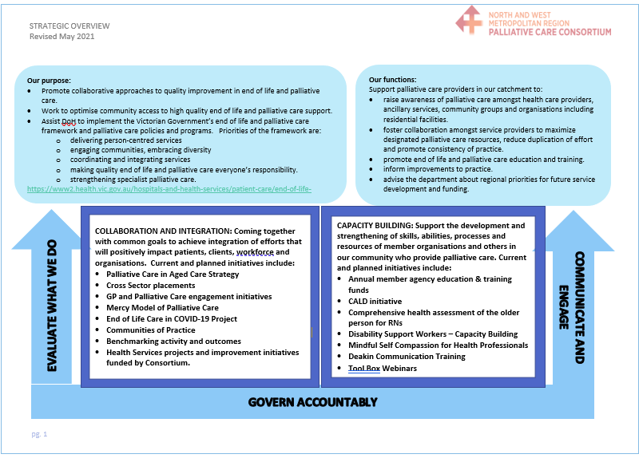In May 2021, the Consortium Management Group agreed its strategic approach for the 2021/2022 financial year and approved its strategic overview.

The strategic overview guides how the Consortium’s resources and efforts are to be directed for the coming 12 months providing clarity for Consortium member agencies and the Consortium Team.

### **OVERVIEW OF WORK BEING UNDERTAKEN IN 2021/2022**

In addition to the projects and initiatives commenced in 2020/2021 period and ongoing, the Consortium is undertaking a range of Health Services Initiatives and Consortium Team activities.

### **CONSORTIUM FUNDED HEALTH SERVICE INITIATIVES**

### **Symptom Management Discharge Plans**

Austin Health will be undertaking its Palliative Care Symptom Management Plan for Discharge from Hospital to Home Project from July 2021 to December 2021. The project aims to develop and implement systems that support the preparation of individualised and documented symptom management plans for patients being discharged from hospital to home, to improve the ability of patients/carers to manage their symptoms at home and improve the transition of care to community service providers.

### **Supportive care in Chronic Kidney Disease**

The Supportive Care in Chronic Kidney Disease initiative being undertaken by Western Health aims to improve access to and timely referrals to palliative care for patients with chronic kidney disease to improve symptom management, improve quality of life and establish Advance Care Directives. The project commenced July 2021 and will be competed May 2022.

### **Access to Aboriginal and Torres Strait Islander informed/co-designed resources**

Commencing August 2021 and continuing until January 2022, the Peter MacCallum Cancer Centre will be undertaking an initiative that aims to improve access to existing Aboriginal and Torres Strait Islander informed / co-designed resources for palliative care service providers. The project will better equip the palliative care service system and providers to provide culturally safe palliative and end of life care provision for Aboriginal and Torres Strait Islander peoples, through improved access to existing patient-facing and health professional resources. Resources will be made available across our Consortium and more widely.

### **Palliative Care in Progressive Neurological Disease**

Northern Health is undertaking a project known as Palliative Care in Progressive Neurological Disease which aims to pilot Palliative Care Physician presence in the fortnightly Northern Health Progressive Neurological Disease Clinic and Multidisciplinary Team Meeting, allowing joint care for predominantly Motor Neurone Disease patients. The project is commencing August 2021 and will be completed June 2022.

### **Standardising Referral information between member agencies**

This improvement opportunity was proposed in July 2021 and aims to identify a minimum information and data set for referral of patients between palliative care units from community or hospital-based services. A working group with representatives from each member agency has been established to scope the initiative, agree an approach, and implement agreed improvement activities.

### **Strengthening capacity of support workers in the disability sector to support palliative care**

This initiative will focus on:

* ‘Palliative approach to care’ education and training for Nurse Practice Advisors who work in the sector including communicating with families and carers. The aim will be to support a ‘train the trainer’ model.
* Providing information and guidance to the sector regarding referral processes including indications for referral to community palliative care.
* Providing information and training regarding Advance Care Planning
* Providing practical training for Support Workers on basic care around end of life, e.g. mouth care, pressure care, skin care, identification of deterioration
* Providing general information for Support Workers regarding palliative care and practical resources to help carers talk with people living with a disability about palliative care, death and grief.

### **Funding Palliative Care education and training for Registered Nurses**

Our Consortium will fund training courses in palliative care for registered nurses from within Consortium member agencies to build capacity of nurses new to the sector and as a way of attracting nurses to palliative care. This training will be promoted broadly across member agencies. Topics to include:

* Introduction to palliative care
* Importance of psychosocial support
* Pain management
* End of life
* Opioid conversions and syringe drivers
* Symptom management part 1 and part 2
* Palliative emergencies, treatments and assessment tools:

### **CONSORTIUM TEAM INITIATIVES**

The Consortium Manager and Consortium Project Coordinator will continue to implement the following initiatives commenced over the 2020/2021 period. These include:

* Rollout of the Cross Sector Clinical Observation Placement Program (dependent on COVID-19 restrictions).
* Capacity building to deliver culturally appropriate care utilising the consultative approach being developed with the Muslim community with other emerging communities.
* Continuing to work with the NWMPHN to build GP engagement in our catchment to reduce challenges and barriers experienced by GPs when providing palliative care.
* Exploring opportunities to establish Communities of Practice in the catchment: one for *Bereavement* and one for *Communication around and at end of life*.
* Planning and scheduling two sessions: ‘*Voluntary Assisted Dying two years: Q&A Session’* with VAD navigators.

# FINANCIAL REPORT

Statement of Income and Expenditure 2020 – 2021 for the North and West Metropolitan Region Palliative Care Consortium re Funding Agreement with the Victorian Department of Health for year ending 30 June 2021.



North and West Metropolitan Region Palliative Care Consortium

C/- Melbourne City Mission Palliative Care

230 Normanby Avenue,

Thornbury, Victoria 3071

Ph:03 9977 0026

Email: [consortium@mcm.org.au](mailto:consortium@mcm.org.au)

Website: [www.northwestpalliative.org.au](http://www.northwestpalliative.org.au)